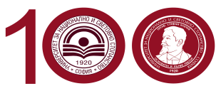

2020-1-EL01-KA203- 078981
Common curricula for diversity:
education in media and integration of vulnerable groups

ERMIS: Transnational Project Management Meeting (TPM), 24-26 March 2022
Venue: University of National and World Economy (UNWE), Big Conference Hall
24 March 2022 Thursday, Venue: Lobby of Hotel Sofia Palace
17:30 -19:00 Initial discussion about the project and its progress.
Meeting at Hotel Sofia Palace; Address: Sofia 1000, Tri Ushi Str. ,No.8
https://www.sofiapalacehotel.com/
19:30 Dinner at Restaurant “Shatstlivetsa”, Vitosha Blvd. no 27. Everyone is ordering and paying for his/her own consumption.
https://www.shtastliveca.com/en/index.html
Menu
https://www.shtastliveca.com/uf/menu/34/vitoshka-eng2.pdf
Map/Location
https://www.google.com/maps/place/bul.+%22Vitosha%22+27,+1000+Sofia+Center,+Sofia/@42.6948781,23.3212358,17z/data=!4m5!3m4!1s0x40aa856ce27cc073:0x6757232d56a5eb87!8m2!3d42.6932734!4d23.3205813
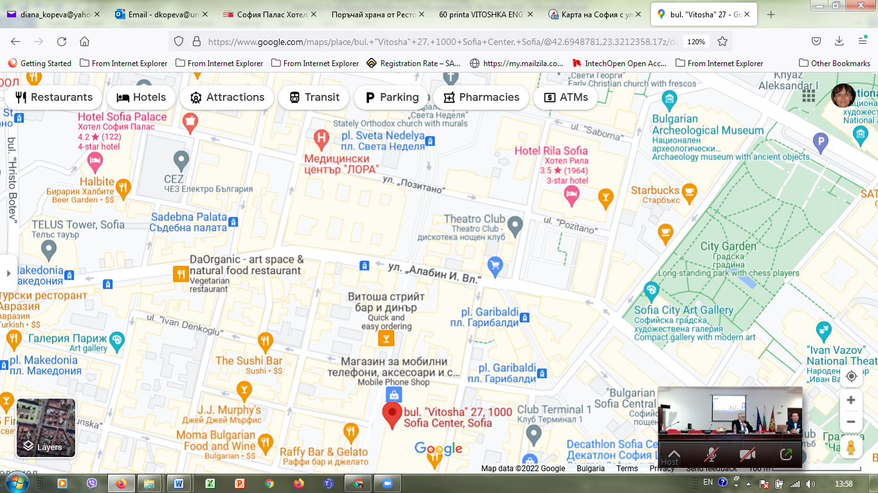

25 March 2022 Friday – Venue: Big Conference Hall, UNWE
9:00 – 09:30 Welcome and Introductory Remarks
Prof. Dimitar Dimitrov, Rector, UNWE
Prof. George Pleios, Head of the Communication and Mass Media Department at the National and Kapodistrian University of Athens (NKUA), Greece
Dr. Savvatou Tsolakidou, Project Coordinator, Special Laboratory and Teaching Staff, NKUA.
09:30 – 10:20 Session 1: Piloting phase results for IOs1-4 (lessons learned, ways to incorporate the feedback in the final deliverable, etc.)
09:30-09:40 Dr. Savvatou Tsolakidou, Piloting phase – what was designed and expected as results according to project proposal
09:40 -09:50 IO1: Stereotypes and Prejudices: Xenophobia & Racism Piloting Phase, Prof. Tirşe Erbaysal Filibeli, BAU
09:50-10:00 IO2: Fake news & hate speech: representation of vulnerable social groups in the media, Assoc. Prof. Stella Angova,
10:00-10:10 IO3: Social entrepreneurship and vulnerable social groups, Prof. Nikolay Dentchev
10:10 – 10:20 IO4: Vulnerable groups and cultural trauma, Dr Savvatou Tsolakidou
10:20-10:40 Coffee Break
10:40 - Session 2 Development progress of theoretical chapters for IOs 5-7 (chapters developed, planning of Piloting for IOs 5-7,
Addendum
10:40 -10:50 IO5: Integration policies for vulnerable social groups, Dr. Savvatou Tsolakidou
10:50-11:00 IO6: Funds & Grants: Social integration and Rights related projects, Prof. Diana Kopeva
11:00–11:10 IO7: Transformative methodological approach: teaching, training, learning, Dr Aura Neuvonen
11:10 – 11:20 Piloting of IO5-IO7
11:20 12:30 IO8: COMMON CURRICULA: Education in Media and Integration of Vulnerable Groups
1. Organization details of Multiplier Event (Mid-Term Conference): by
EKO in April 2022, Athens, Greece
2. Organization details of Learning, Teaching, Training Activity No 1 (C1): by BAU in May 2022, Istanbul, Turkey
12:30-13:30 Lunch
13:30-14:30 Session 3: Discussion on the format of the final deliverable (digital ERMIScom book) /
14:30 -15:30 Common Dissemination & Visibility Actions
15:30 – 15:45 Coffee Break
15:45-16:15 Session 4: Process Evaluation of the Project
16:15 – 17:15 Session 5: Future Steps and Follow-up projects
17:15-17:30 Conclusions of Day2: summarizing the discussions
26 March 2022 Saturday; Venue: Big Conference Hall, UNWE
10:00 – 10:30 Session 1: Process Evaluation of the Project (continuation)
10:30 – 11:00 Session 2: Future Steps and Follow-up projects (continuation)
11:00- 11:30 Coffee Break
11.30-12.30 Closing the TPM and summarizing the discussions
DEPARTURE

