ERMIScom_Process Evaluation Form

Transnational Partner Meeting [1-3]...........

The form serves as one of the tools of internal quality evaluation of ERMIScom project. The aim of this process is the determination of the quality and effectiveness of the project’s design, content and implementation. Evaluation efforts will identify potential barriers and opportunities related to the project implementation. is the determination of the quality and effectiveness of the project’s design, content and implementation.

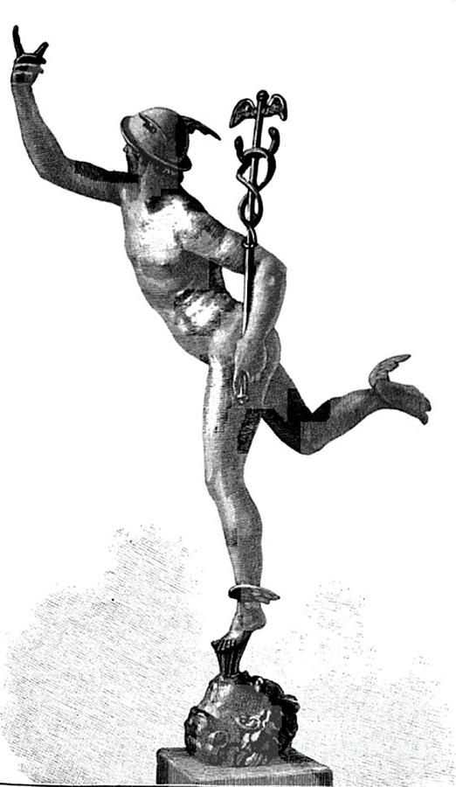

Project number: 2020-1-EL01-KA203- 078981

"This project has been funded with support from the European Commission. This publication reflects the views only of the author, and the Commission cannot be held responsible for any use which may be made of the information contained therein"

Structure of the project
Grading | Poor | OK | Good | Very Good | Excellent
I share a common understanding of what the project is about | 1 | 2 | 3 | 4 | 5
I am familiar with the project's aims and objectives | 1 | 2 | 3 | 4 | 5
I am familiar with the project's target groups | 1 | 2 | 3 | 4 | 5
I know about all the partners' tasks in the project | 1 | 2 | 3 | 4 | 5
I know my organisation's tasks in the project | 1 | 2 | 3 | 4 | 5
The project has a clear structure. The workflow follows a logic sequence. | 1 | 2 | 3 | 4 | 5
The work process is quite clear to me | 1 | 2 | 3 | 4 | 5
Comments:

Implementation of the project activities
Grading | Poor | OK | Good | Very Good | Excellent
Project activities comply with the overall objectives of the project | 1 | 2 | 3 | 4 | 5
Deliverables correspond with the activities description as specified in the Application Form | 1 | 2 | 3 | 4 | 5
It’s possible to realize all project activities till the end of the project | 1 | 2 | 3 | 4 | 5
Comments:

Dissemination
Grading | Poor | OK | Good | Very Good | Excellent
The web site of the project gives precise and updated information on the project objectives and activities | 1 | 2 | 3 | 4 | 5
Promotional materials reflect the visual identity of the project | 1 | 2 | 3 | 4 | 5
Project is well presented in the media | 1 | 2 | 3 | 4 | 5
Comments:

Management of the project
Grading | Poor | OK | Good | Very Good | Excellent
Communication channels are sufficient to achieve excellent project results | 1 | 2 | 3 | 4 | 5
Coordinator informs all partners on all aspects of activity implementation | 1 | 2 | 3 | 4 | 5
Coordinator informs all partners on financial aspects of the project realization | 1 | 2 | 3 | 4 | 5
If conflict arose, the partners were able to solve it | 1 | 2 | 3 | 4 | 5
Project events (conferences, workshops, trainings, and study visits) are well structured | 1 | 2 | 3 | 4 | 5
Project events have good prepared agendas sent on time | 1 | 2 | 3 | 4 | 5
Project events provide enough opportunities to discuss and exchange ideas | 1 | 2 | 3 | 4 | 5
Project events prepare us well for the next steps of the project work | 1 | 2 | 3 | 4 | 5
The management meetings are usually concise and informative | 1 | 2 | 3 | 4 | 5
The minutes of the partners' meetings provide full information, are accurate, clear and useful | 1 | 2 | 3 | 4 | 5
Comments:

Partnership
Grading | Poor | OK | Good | Very Good | Excellent
All members of the consortium put much effort in their tasks | 1 | 2 | 3 | 4 | 5
All members of the consortium take responsibility for project activities and results | 1 | 2 | 3 | 4 | 5
All members of the consortium are acknowledging skills and expertise of other project members | 1 | 2 | 3 | 4 | 5
The partnership motivates us to collaborate with the partners in future projects | 1 | 2 | 3 | 4 | 5
Comments:

Exploitation
Grading | Poor | OK | Good | Very Good | Excellent
Exploitation of the project's results is well determined | 1 | 2 | 3 | 4 | 5
It’s possible to extend project impact during and after project lifetime | 1 | 2 | 3 | 4 | 5
Sustainability of the project is well planned | 1 | 2 | 3 | 4 | 5
Comments:

