Individual Evaluation Form

(LTT or Study visit.............)

The form serves as one of the tools of internal quality evaluation of ERMIScom project. The aim of this process is the determination of the quality and effectiveness of the project’s design, content and implementation. Evaluation efforts will identify potential barriers and opportunities related to the project implementation. is the determination of the quality and effectiveness of the project’s design, content and implementation.

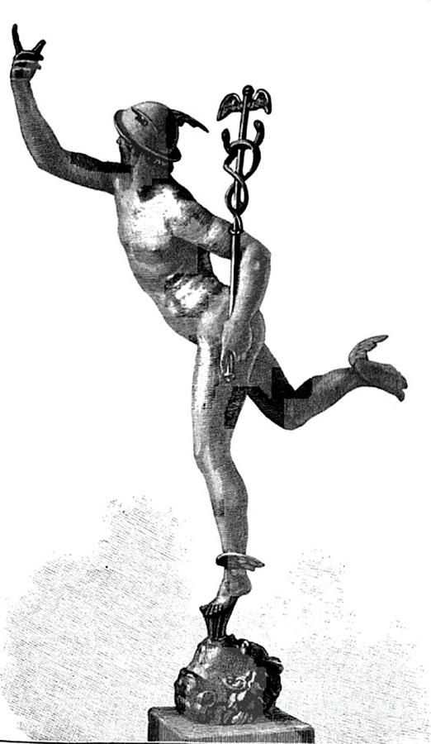

Project number: 2020-1-EL01-KA203- 078981

"This project has been funded with support from the European Commission. This publication reflects the views only of the author, and the Commission cannot be held responsible for any use which may be made of the information contained therein"

- Structure of the LTT activity or the Study visit
Grading | Very disatisfyed | Disatisfied | Neutral | Satisfied | Very satisfied
- Indicate your level of satisfaction with the agenda of the LTT or the SV
- Quality of the organization
- Achievement of the LTT or the study visit’s goals and objectives
- Communication before and during the LTT or the Study Visit
Implementation of the LTT or SVactivities
Grading | Very disatisfyed | Disatisfied | Neutral | Satisfied | Very satisfied
- At what level are you satisfied ofthe roject activities comply with the overall objectives of the project
- The activities of the LTT or the SV provide enough opportunities to discuss and exchange ideas between the participants
- At what level are you satisfied regarding the resolution of administrative or organisational problems and the flexibility of the hosting partner to solve unexpected problems
Dissemination
Grading | Very disatisfyed | Disatisfied | Neutral | Satisfied | Very satisfied
- The Events, LTT and SV were presented in the Universities activities and in the web side of the Project
- Has the communication with the host institution been clear and efficient

II. PURPOSE AND SUSTAINABILITY
Please indicate your level of satisfaction on the scale from 1 (not at all satisfied) to 5 (very much satisfied):
10. Identified topics of presentations
 | 1 | 2 | 3 | 4 | 5
Not at all |  |  |  |  |  | Very much
11. Quality of presentations and coverage of subjects
 | 1 | 2 | 3 | 4 | 5
Not at all |  |  |  |  |  | Very much
12. Topic coverage and relevance
 | 1 | 2 | 3 | 4 | 5
Not at all |  |  |  |  |  | Very much

13. Have all planned activities of the study visit been achieved?
yes
no
Other, explain....................................................................................................................
III. GENERAL SATISFACTION
Please indicate your level of satisfaction with:
Grading | Very disatisfyed | Disatisfied | Neutral | Satisfied | Very satisfied
14. Shared experiences and good practices
15. The possible ongoing relationships with the host country or its institutions

16. Are there any other comments or suggestions you would like to share with us?

Thank you for your answers!

