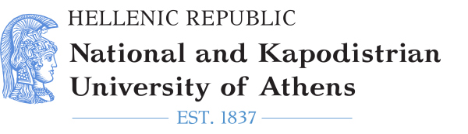
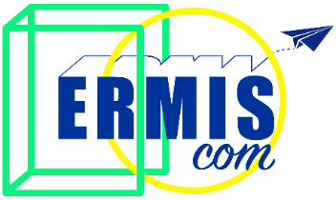
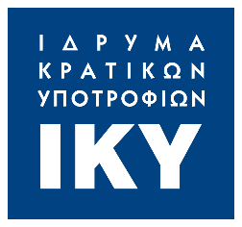
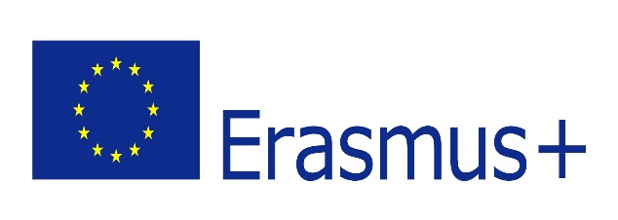

ERMIScom Conference
Hosted by Entrepreneurship and Social Economy Group (EKO)
The first Conference organized in the context of ERMIScom project will be hosted on April 6 and 7, 2022, at Stanley Hotel in Athens, Greece. This two-day event aspires to bring a multidisciplinary audience of relevant stakeholders, to initiate a vivid discussion about the contemporary challenges of mass-media education, with special focus on the existing skills-gaps that undermine effective, objective, and responsible media representation of vulnerable social groups and hence, contribute to the perpetuation/exacerbation of labelling, stereotypes and other polarizing phenomena.

Wednesday, April 6, 2022
10:00 – 10:30 | Registration
10:30 – 10:45 | Opening Statements from the project’s Coordinator-NKUA and EKO
10:45 - 11:15 | Summary of the Programme
11:15 – 11:45 | Stereotypes and prejudices: “Xenophobia and racism” (IO1)  Assist. Prof. Sinan Aşçı, Bahçeşehir University, New Media Department
11:45 – 12:00 | Break
12:00 – 12:30 | Fake news and hate speech: “Representation of vulnerable groups in the Media” (IO2)  Prof. Dr. Diana Kopeva, University of National and World Economy, Business Faculty  Dr. Ani Arutyunyan, University of National and World Economy, International Relations and Politics Department
12:30 – 13:30 | Panel Discussion: “Mass Media and Vulnerable Groups: An educational challenge”  Prof. George Pleios, Dr. Giorgos Georgarakis, Dr. Alexandros Minotakis, National Kapodistrian University of Athens, Communication and Media Department  Dr. Ani Arutyunyan, University of National and World Economy, International Relations and Politics Department
13:30 – 14:30 | Light Lunch
14:30 – 15:30 | Expert talk: “Hate Speech & Fake News: Vulnerable communities and the media”  Prof. Caroline Elias, American University of Cairo, Journalism and Mass Communication Department - representative of MAAT for Peace
15:30 – 16:00 | Social Entrepreneurship and vulnerable social groups (IO3)  Claudia Alba, PhD(c), Vrije Universiteit Brussel, Business Department (BUSI)
16:00 – 16:30 | Break
16:30 – 17:00 | Vulnerable groups and Trauma (IO4)  Dr. Mike Tastsoglou & Dr. Alexandros Minotakis, National Kapodistrian University of Athens, Communication and Media Department

Thursday, April 7, 2022
10:00 – 10:30 | Registration
10:30 – 11:00 | Presentation of Development Progress of Intellectual Outputs (IOs) 5 “Social Policies for Vulnerable Groups” and 6: Funds & Grants: social integration and rights related projects”  Dr. Savvatou Tsolakidou, National Kapodistrian University of Athens, Communication and Media Department, Coordinator of the Project.
11:00 – 11:30 | Insights from IOs development and Piloting Results -Working methods and Challenges  Dr. Savvatou Tsolakidou, National Kapodistrian University of Athens, Communication and Media Department  Prof. Diana Kopeva, University of National and World Economy, Business Faculty  Assist. Prof. Figen Algül, Marmara Üniversitesi, Communications & Media Studies
11:30 -12:00 | Transformative Methodological Approach - Teaching, Training, Learning in Media Education (IO7)  Prof. Aura Kaarivuo, Helsinki Metropolia University of Applied Sciences, Mass Media Department
12:00 – 12:15 | Break
12:15 – 12.45 | Presentation of ERMIScom Addendum  Elisavet Vasileiou, Entrepreneurship and Social Economy Group
12:45 – 13:30 | Non-formal education principles in Media Education: Evaluating Media Information in the representation of Vulnerable Social Groups in the Media  Elisavet Vasileiou & Alicia Vidal, Entrepreneurship and Social Economy Group
13:30 – 14:30 | Light Lunch
14:30 – 15:30 | Experiential learning methods in Media education: Understanding Discriminative Discourse  Elisavet Vasileiou & Alicia Vidal, Entrepreneurship and Social Economy Group
15:30 – 16:00 | Closing statements - Evaluation and Feedback Forms

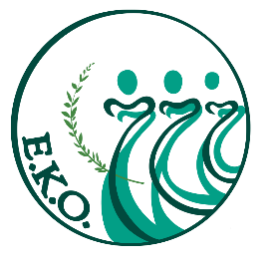
Conference Organizer & Host
ENTREPRENEURSHIP AND SOCIAL ECONOMY GROUP
https://ekogreece.com/

Context
The Conference is organized by the Entrepreneurship and Social Economy Group (EKO) in the context of the Erasmus+ - Strategic Partnerships for Higher Education project “Common curricula for diversity: education in media and integration of vulnerable groups - ERMIScom” (2020-1-EL01-KA203- 078981)

https://ermiscom.media.uoa.gr/
Conference Contributors
ERMIScom Project Coordinator:
NATIONAL KAPODISTRIAN UNIVERSITY OF ATHENS
ERMIScom Project Co-Beneficiaries:
- BAHCESEHIR UNIVERSITESI FOUNDATION
- ENTREPRENEURSHIP AND SOCIAL ECONOMY GROUP
- METROPOLIA AMMATTIKORKEAKOULU OY
- UNIVERSITY OF NATIONAL AND WORLD ECONOMY
- VRIJE UNIVERSITEIT BRUSSEL
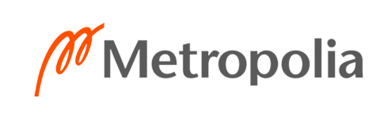
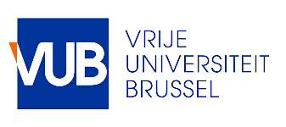
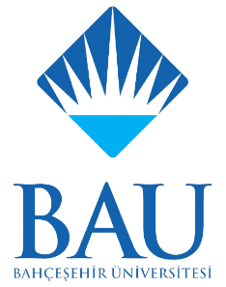
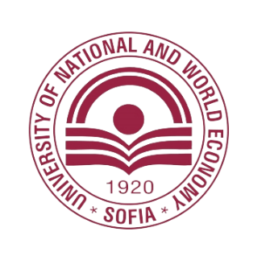
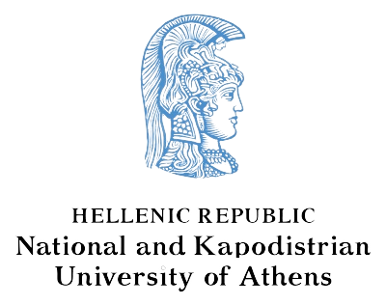

ERMIScom Associated Partners:
- MAAT FOR PEACE, DEVELOPMENT AND HUMAN RIGHTS (EGYPT)
- HUMANRIGHTS360 (GREECE)
