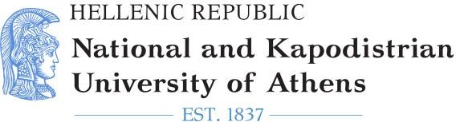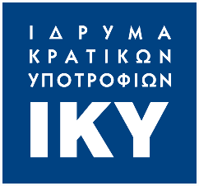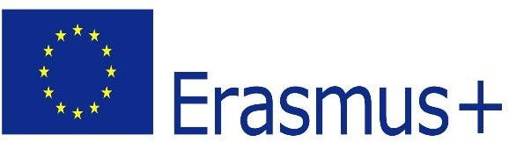

2020-1-EL01-KA203- 078981
Common curricula for diversity:
education in media and integration of vulnerable groups

ERMIScom: Transnational Project Management Meeting
Last TPM, 8 & 9 February 2023

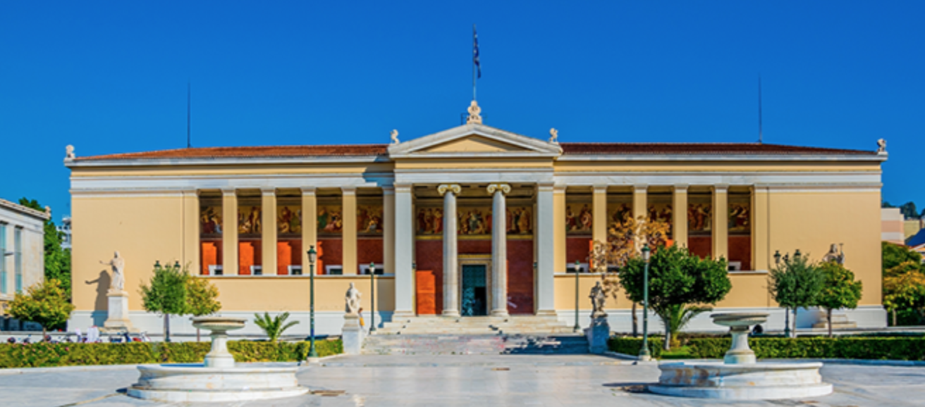

Venue: National Kapodistrian University of Athens (NKUA)
Department of Communication and Media Studies

Address: Grypareio Megaron, 1, Sophocleous str., Athens, 105 59
Meeting Room: 3rd floor

8 February 2023 Wednesday

09:30 - 09:45 | - Welcome and introduction  - Agenda and Meeting Objectives
09:45 – 11:00 | Discussion on completed project activities and outputs
11:00 – 11:20 | Coffee break
11:20 – 13:00 | Overview and discussion on implemented dissemination & publicity activities
13.00 – 14:00 | Lunch
14:00 – 15:30 | Overview and discussion on implemented evaluation activities and evaluation report
15:30 – 15:50 | Coffee break
15:50 – 17:00 | Project Management, Budget & Implementation  - financial & administrative issues  - elaborating final report  - tasks need to be done until the end of the project

9 February 2023 Thursday

09:30 - 09:45 | - Overview and discussion on implementation of the new project  - Project Partnership- involvement of new partners
09:45 – 11:00 | - New project activities and outputs
11:00 – 11:20 | Coffee break
11:20 – 13:00 | - Work packages 2, 3 and 4
13.00 – 14:00 | Lunch
14:00 – 15:30 | Dissemination activities (work package 5)
15:30 – 15:50 | Coffee break
15:50 – 17:00 | Project Management (work package 1), Budget & Implementation  - Distribution of tasks  - Preparation of the new proposal  - Coordination and application  Closing the TPM and summarizing the discussions

